Report on Project Design Phase 1

### Real-Time Communication System Powered by AI For Specially Abled

**Problem Statement:**

Even though human and his technologies have improved a wide, these technologies can never match the human sense. Especially, when it comes to specially abled person, the human sense plays vital than using normal technologies. But when Artificial intelligence is concerned, the technology gets nourished with the human sense. The disabilities of specially abled person can be overcome by means of artificial intelligence. There may be lack of accuracy and reliability, by implementing the existing AI methodologies. Here accessibility must be mainly focused. A lot of apps use artificial intelligence to favour accessibility. Depending on the type of disability of the person, communicating with others can be a challenge, AI can be at the service of people with disabilities at its highest accuracy. Convolution neural network can be used to create a model that is trained on different hand gestures. The app can be developed which enables deaf and dumb people to convey their information using signs which get converted to human-understandable language. This improves their ease of communicating without difficulties.

**Solution Description:**

In our project, we add the train and test set of data in the neural network. These datasets are derived by the means of image processing under a specific image dataset. These image processing is done by python coding in depth. Once the datasets are tested and trained, they get stored in the neural network for data fetching. When the user asks for data recognition, it is sensed by the user interface of the project model. The image thus identified is processed by image processing technologies implemented in the project device. Then the image is compared with the test and train dataset in the neural network and the result is given as vocal output in the inbuilt voice system in the project device of the user. Also, when the particular object is spoken or specified by the user vocal, the data is checked in the dataset and the location is instructed to the user. By this project, the data is recognized and directing is done to the specially abled person.

**Novelty:**

Ensuring secure and safe mobility for the visually impaired is a complex task that requires precision and effectiveness. In prevailing detection systems for the visually impaired, it detects only the object which the user points at. But in this approach we have introduced an object recognition system that will be able to detect all the objects and obstacles present in front of the user and this helps the user to get more information about what is present in their surroundings. This approach also helps the visually impaired to find an object which the person needs and this will guide them to find the object of their choice. This can also improve the accuracy of the detection system comparing to the detection systems for the visually impaired that are already in existence. This helps the visually impaired for a secure and safe movement in indoor and outdoor environments.

**Social Impact:**

For people with disabilities, mobility proves to be one of the most challenging issues to overcome. How can wheelchair users get around in the city in an autonomous and serene way when they constantly need to be aware of the location of environment. In our article How to Help People with Disabilities Get a Better Experience on the obstacles, we saw that people with disabilities need to rigorously prepare every trip they make. Luckily for them, a lot of navigation apps based on AI technology can help them gain more autonomy and more spontaneity when they’re getting around.

**Business Model:**

The project has a specified architecture where the neural network is involved in the process. The neural network involves the test dataset and train dataset. These datasets are used in fetching and comparing the data with the input images. The business model of the project is as follows,

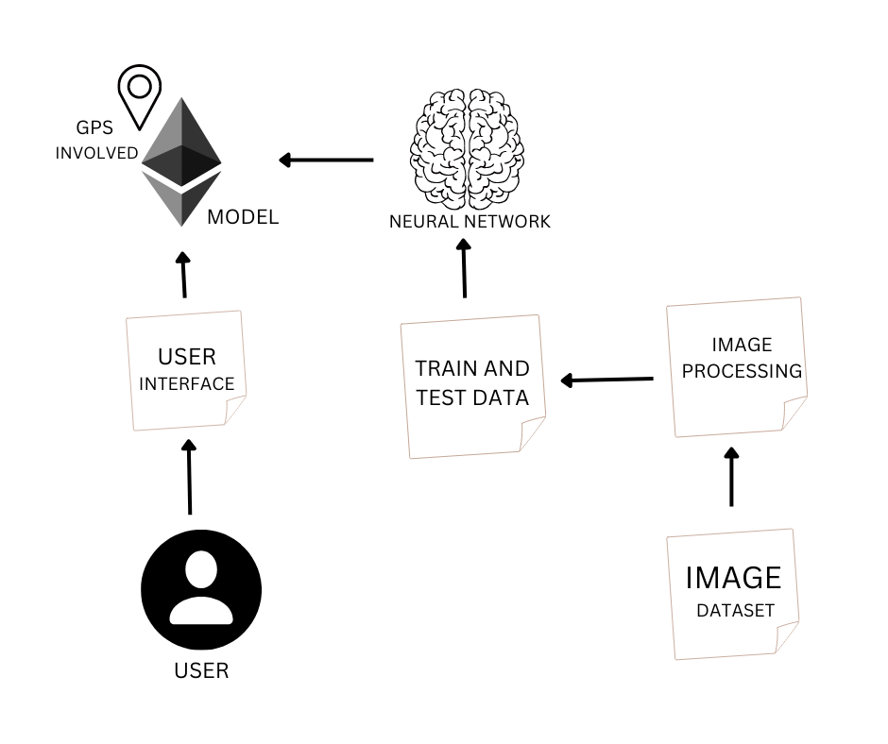

**Scalability of Solution:**

By using this project any visually abled person can take a move like an ordinary person. This device will scan the object in front of the person wearing this device. This will increase the accuracy by checking multiple objects around the surroundings. This will also increase the voice control for using several options like scanning QR codes. This can be easily used by even an ordinary person in all aspects. Also, when it has high accuracy, the capability will be increased.